Overview
The Personal information screen displays a concise summary of information held by the department about you.

The Personal information screen
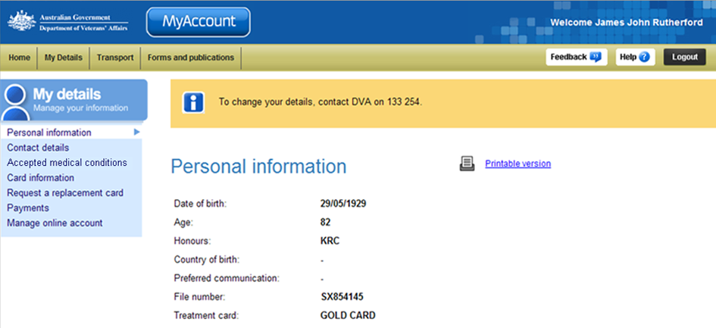
My details menu.
This Personal information cannot be edited within MyAccount. If any details on this screen are incorrect, please call the Veterans’ Access Network (VAN) on 1800 555 254 or email: generalenquiries@dva.gov.au to request a change.

Other functions
 | To view another section and information from My details, click on a link in the My details menu to the left of the page.
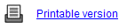 | To print a copy of the information displayed on this page, click on the Printable version link.
 | To get additional help with the Personal information screen, click on the Help button at to the top right of the page.
 | When you are finished using MyAccount, to log out and finish using the service in a secure way, click on the Logout button.

